
DZ-400/2E Single Chamber Vacuum Packing Machine

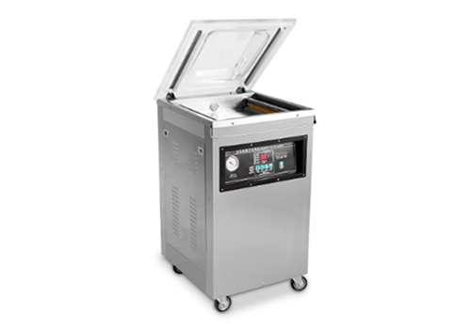

DZ400/2E Table type vacuum packing machine is featured by processing of vacuuming, sealing, cooling, which is used in vacuum packaging for the food, pharmaceutical, aquatic, chemical and electronic industries. It can prevent the products from oxidization and mildew, as well as corrosion and moisture, keeping the quality and freshness of the product over a prolonged storage time.

PARAMETER DATA

Model | DZ-400/2E
Voltage | AC220/50HZ, 110V/60HZ
Motor Power | 1000W
Sealing Power | 500W
Ultimate Vacuum Pressure | 1 KPA
No.of Sealing Bars for Each Chamber | 2 pcs
Chamber Dimension (LxWxH)(mm) | 435*420*75mm
Sealing Length (mm) | 400
Sealing Width (mm) | 10
Vacuum Pump Rate (m³/h) | 20
Material for Vacuum Chamber | Stainless steel
Dimension (LxWxH)(mm) | 540*490*950
Net Weight (kg) | 62
Distance from sealing bar to chamber side (mm) | 370

