
FM-20 Powder Filling Machine

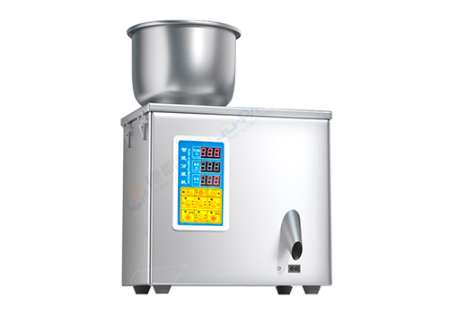

The 20g small quantitative filling machine produced by JD is suitable for the quantification, weighing and filling of tea flower tea, dry products, cereals, cat food and dog food, chemical fertilizer feed, Chinese jujube wolfberry, nuts and sunflower seeds, corn seeds, coffee beans, and other particles and materials

Technical parameters:

- Name: 20g powder filling machine
- Weighing range: 1-20G
- Repacking speed: 10-15 times / min (depending on materials)
- Accuracy: about 0.2 G (depending on the material)
- Hopper capacity: Rice :about 5kg, flour: about 6kg
- Hopper size: Rice: 21 * 18cm
- Discharge nozzle size: Round discharge port
- Voltage / power: 220V / 50HZ (can be changed to 110V/60HZ)
- Machine weight: 8kg
- Overall dimension: 37*22*50CMcm (L*W*H)

