
Check Weigher TOPY-100/1200/3000g

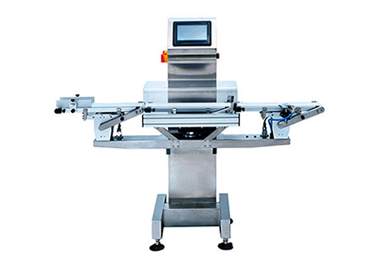

Applied to automatic online package weighing and sorting. Auto-Statistic function turn weighing, maintenance, operation, statistic to more easier.

Features

- Strong stainless steel structure; Water proof design.
- High accurate load cell; Based on advanced DSP technology.
- Automatic weighing compensation and zero tracking.
- 100 products preset; Easy to edit and recall.
- Quickly product shift and speed recall.
- 2000 sorting records; Printer output ready.
- LCD with Touch screen; Friendly operation interface.

Parameter

Model | TOPY-100g | TOPY-1200g | TOPY-3000g
Measurement | Strain Guage
Rejection | Air Jet / Flapper / Pusher / Falling Drop (Option)
Operation | Touch Screen
Alarm | Buzzer & Lamp
Check Range | 3-100g | 10-1200g | 30-3000g
Accuracy | +-0.1 | +-0.5 | -1
Check Speed(Max) | 60 bags/min | 150 bags/min | 100 bags/min
Belt Speed | 30 m/min | 13-96 m/min | 13-70 m/min
Package length | 10-130mm | 60-300mm | 60-350mm
Package Width | 10-130mm | 20-200mm | 30-250mm
Package Height | 10-130mm | 10-200mm | 10-330mm
Weight Size | 300x130mm | 400x220mm | 500x300mm
Power | AC110V/220V 50-60HZ
Rated Output | Appr.200W
Dimension | 1468mm(L)*558mm(W)*1285±35mm(H)

