
DC-200H High-speed Automatic Horizontal Cartoner

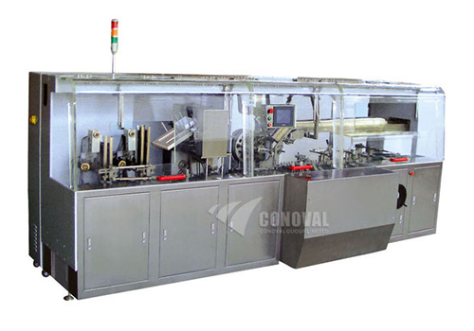

DC-200H Fully Automatic High-speed Cartoning Machine is a high performance product incorporated with mechanical and electrical technology, which is on the basis of imported foreign advanced facilities and innovative designed by ourselves. The concerning technology reaches to the Europe standard and conforms to"GMP"standard.

This machine belongs to level successive operation and the maximum speed can reach to 200 boxes/min.

It's suitable for medicine, food, commodity, chemical, hardware and electronic etc industries packaging sheets, tubes, bottles and lumpish goods. It can connect with blister packaging machine, filling machine and so on, also it can connect with heat contraction film packaging machine and boxing and packaging machine to form complete assembly line.

Technical Parameter

- Boxing Speed: 200 boxes/min (Bottle: 160 bottles/min)
- Cardborad box Dimensions (L×W×H): A 55×20×12mm≤200×70×70mm B≤220×120×70mm
- Unfolded Leaflets Size: 70~210×150~260mm
- Folded Leaflets Size: 70~210×20~40mm
- Main Motor Power: 2.2KW
- Power Supply: 380V 50Hz (200V 60Hz)
- Air Compressor: 0.6 Mpa
- Dimensions of the machine (L×W×H): 4000×1200×1700mm
- Weight: 2400Kg

