
Aseptic Filling Machine for Liquid Medicine

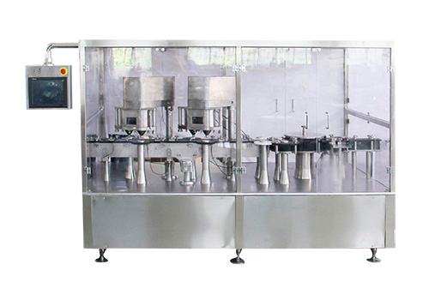

Fully automatic filling machine is developed by our factory on the basis of digesting and absorbing advanced German technology.

It is a new type of filling equipment with advanced level in the world. This machine adopts disc positioning type with high filling accuracy.

Features

1. Man-machine dialogue interface setting, intuitive and convenient operation, accurate loading.
2. Variable frequency control, arbitrary adjustment of production speed, automatic counting.
3. Automatic stop function, no bottle without filling.
4. Wide mesh belt into the bottle, suitable for various bottle types

Technical Parameter

Production capacity | 150 bottles / minute
Packing heads | 8
Number of rolling heads | 12
Loading range | 3-60g (customer specified)
Filling accuracy | ≤ ± 3% (depending on the trial specifications)
Power source | 220V 50Hz
Total power | 5Kw
Production line Dimension | 5000 × 1800 × 1800MM
Weight | 2300Kg

